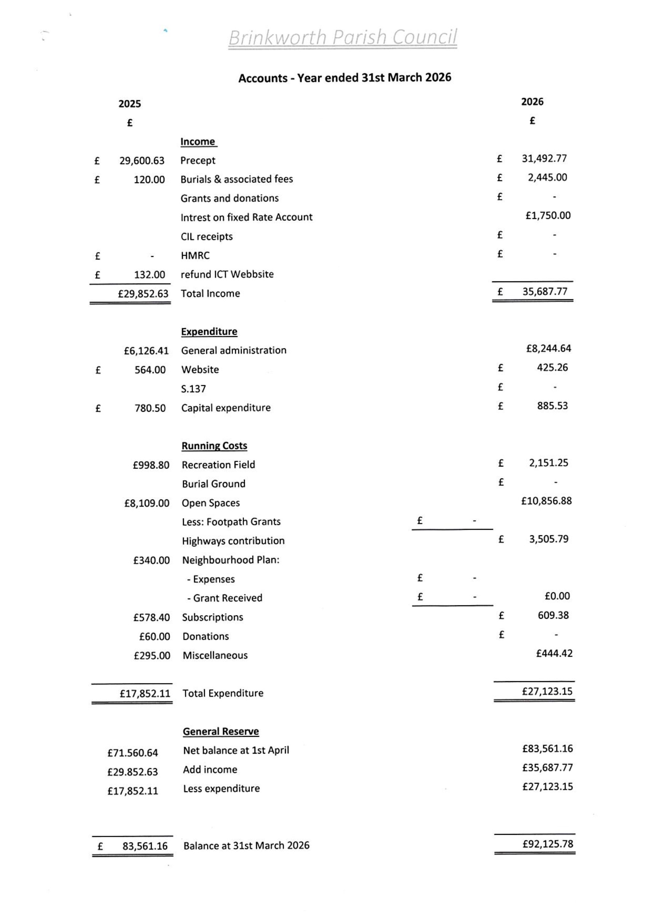
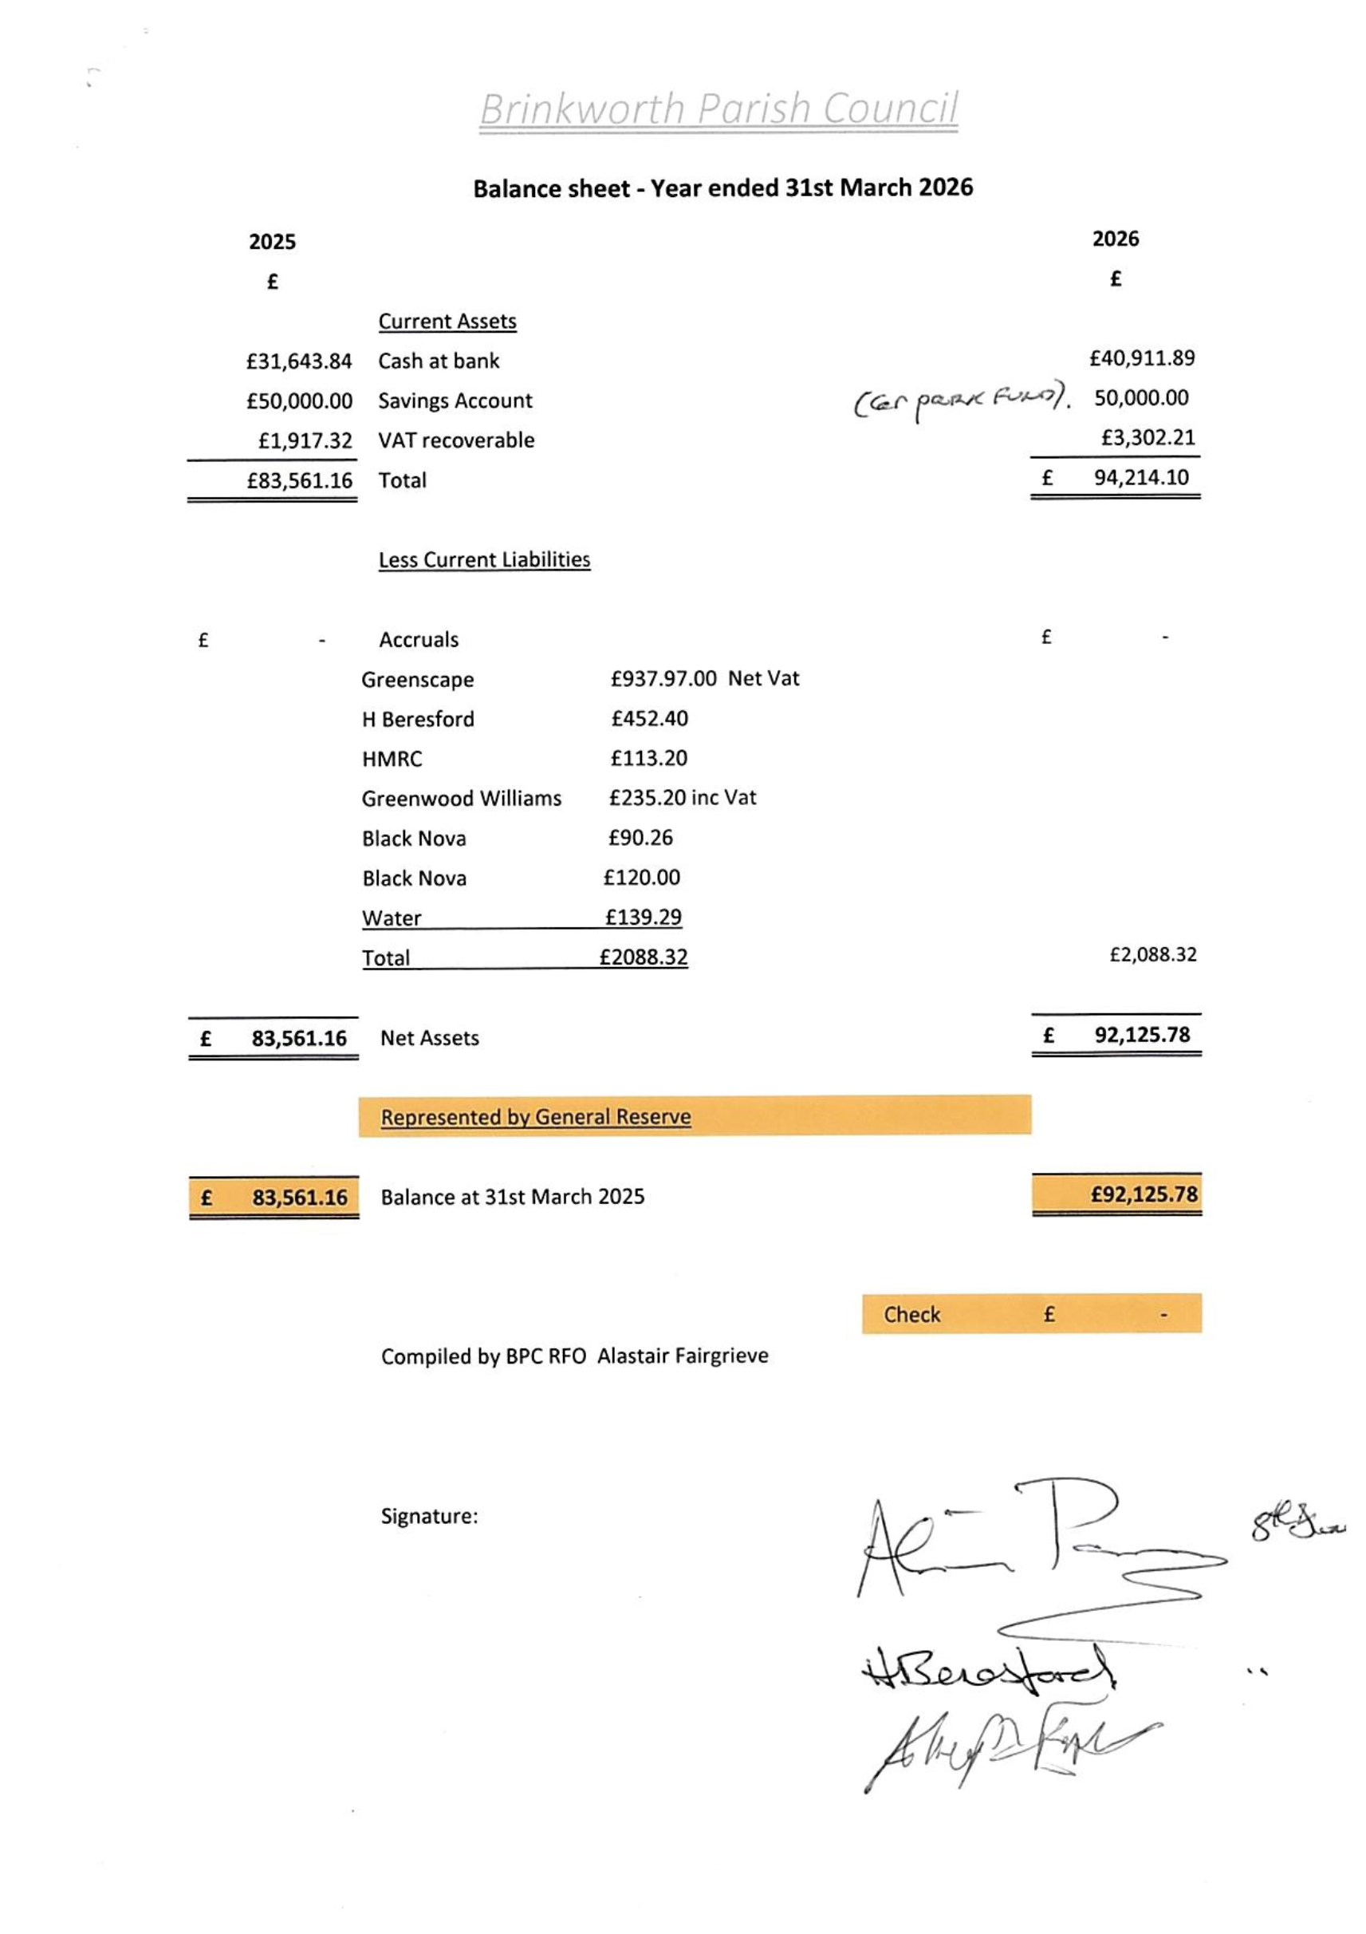
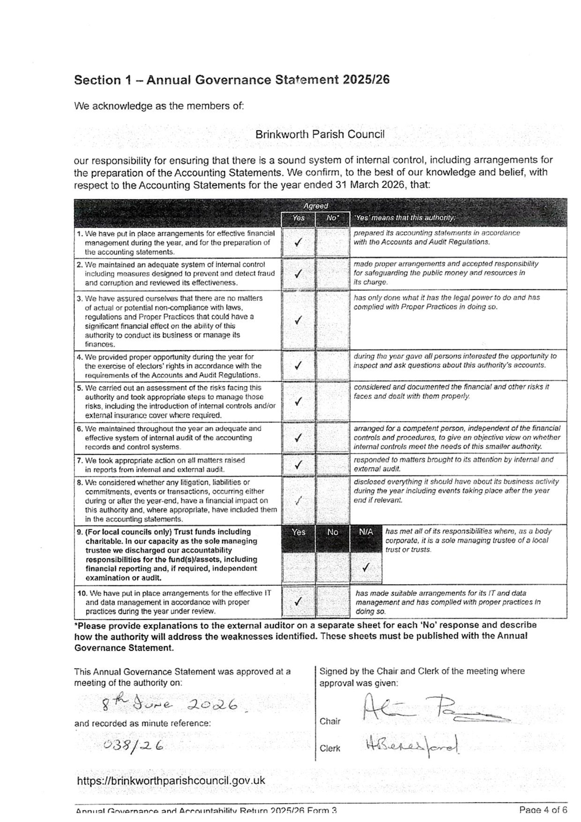
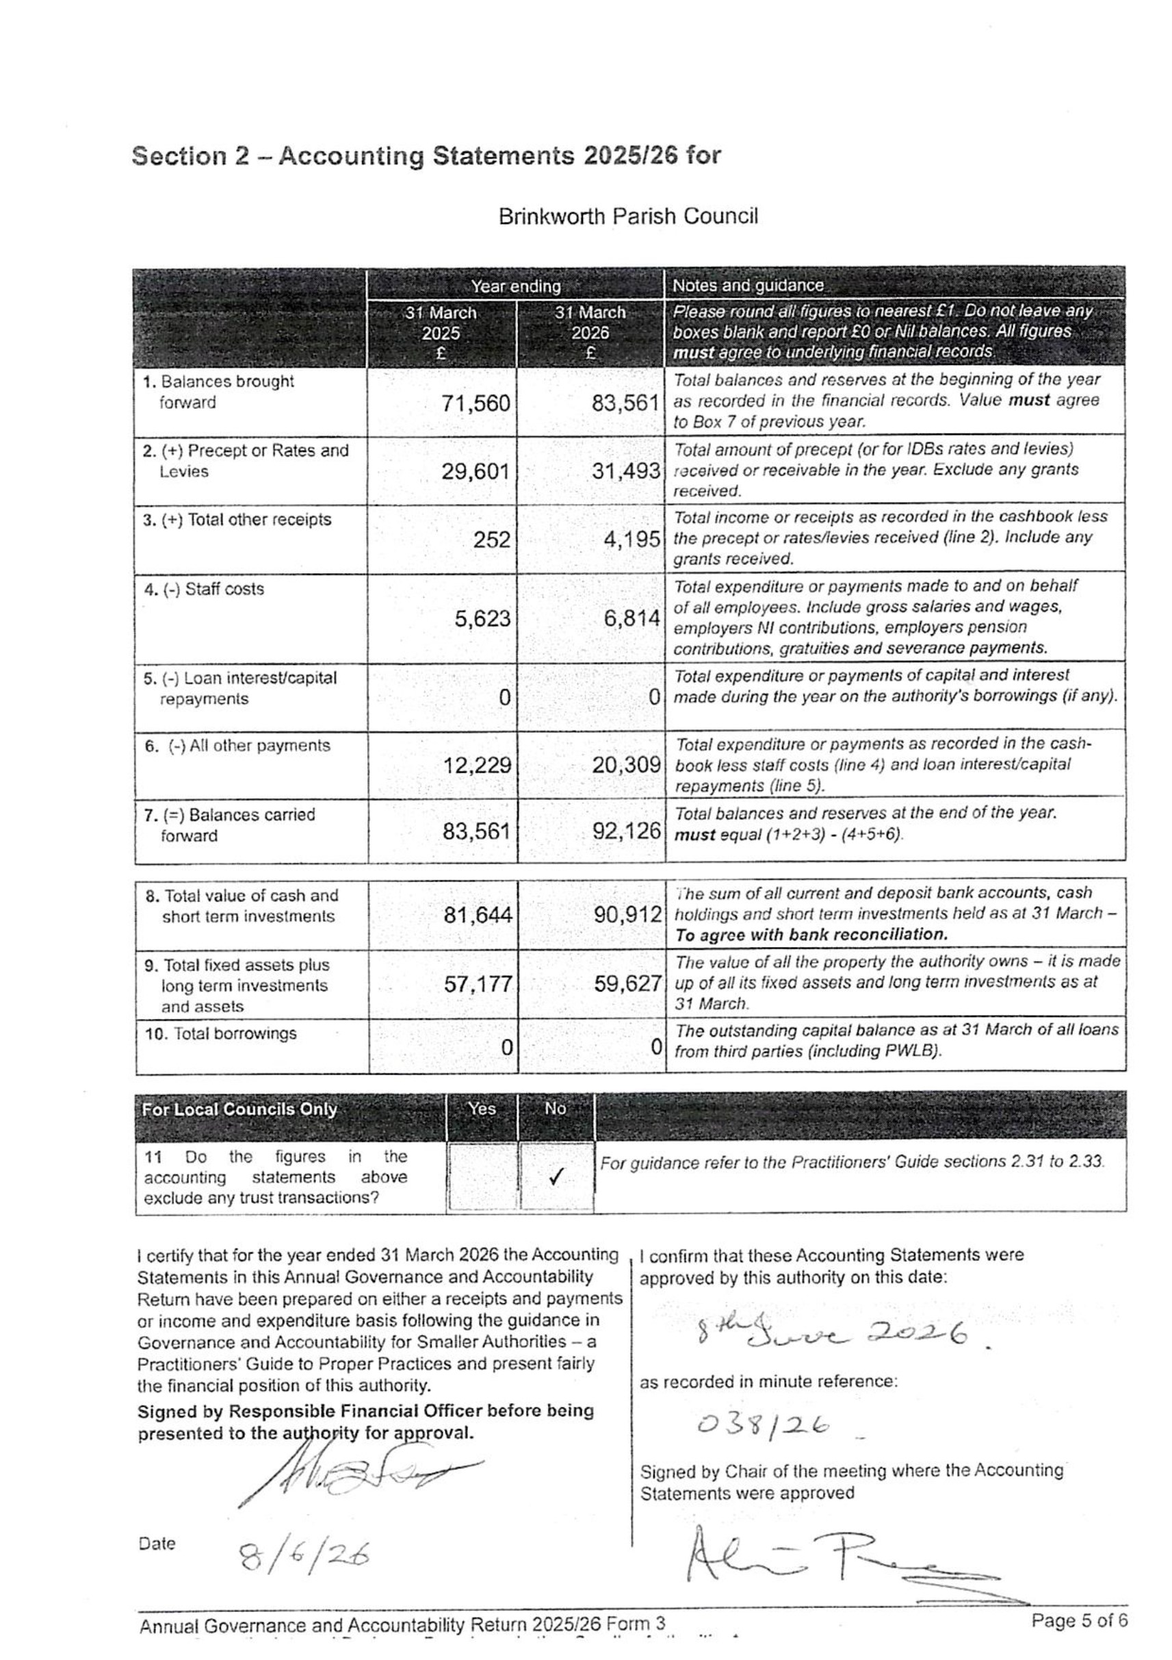
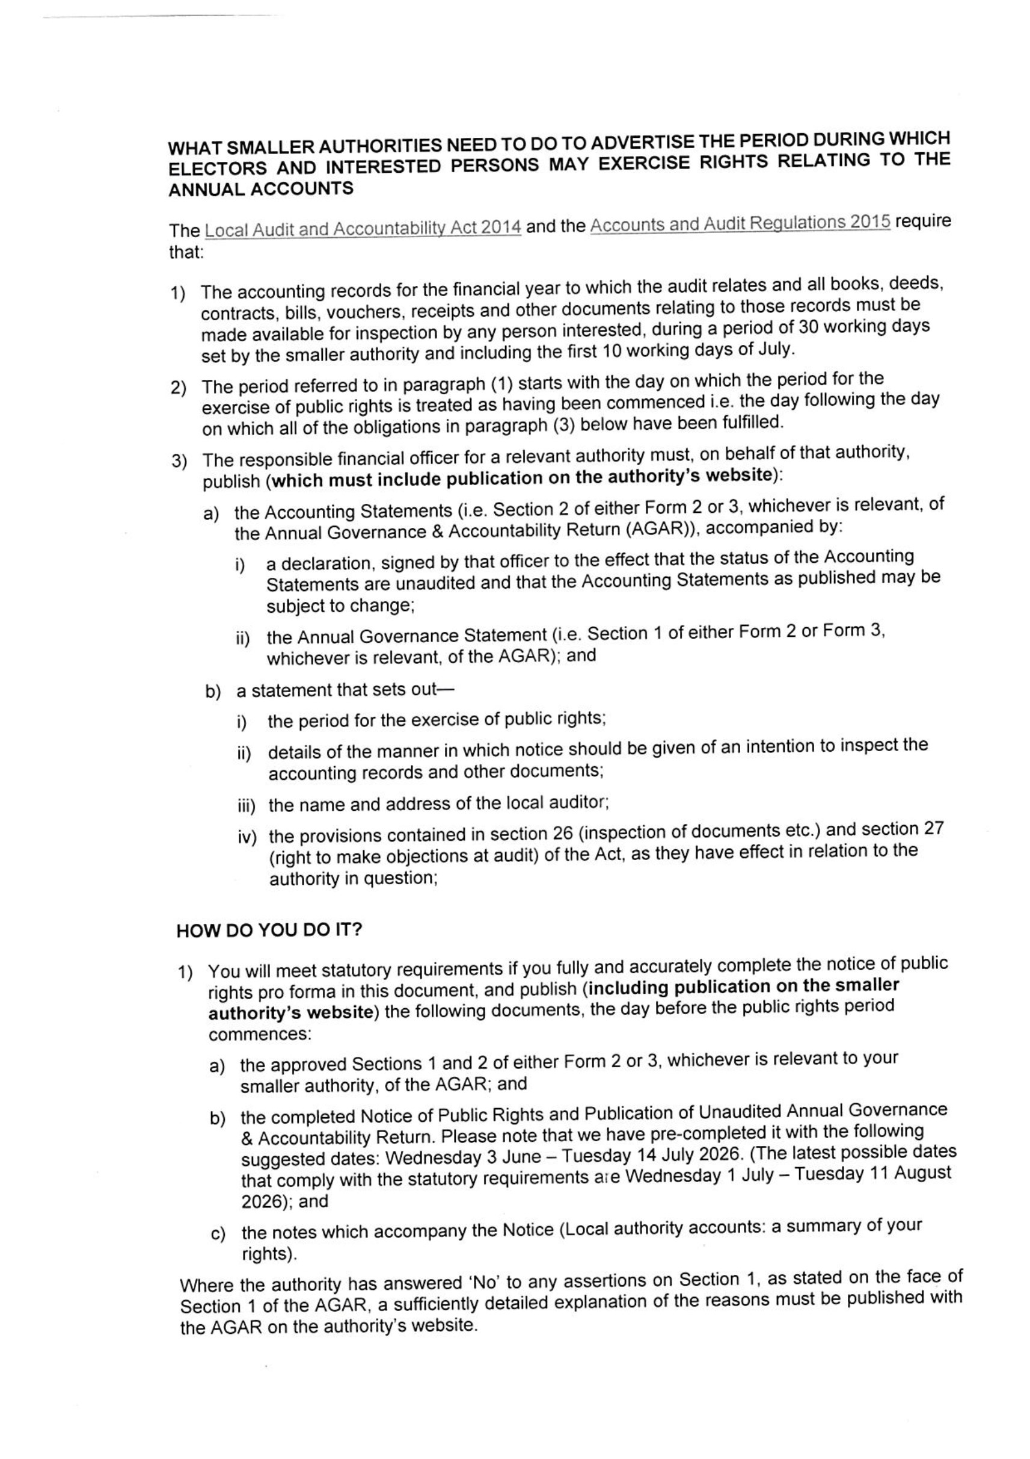
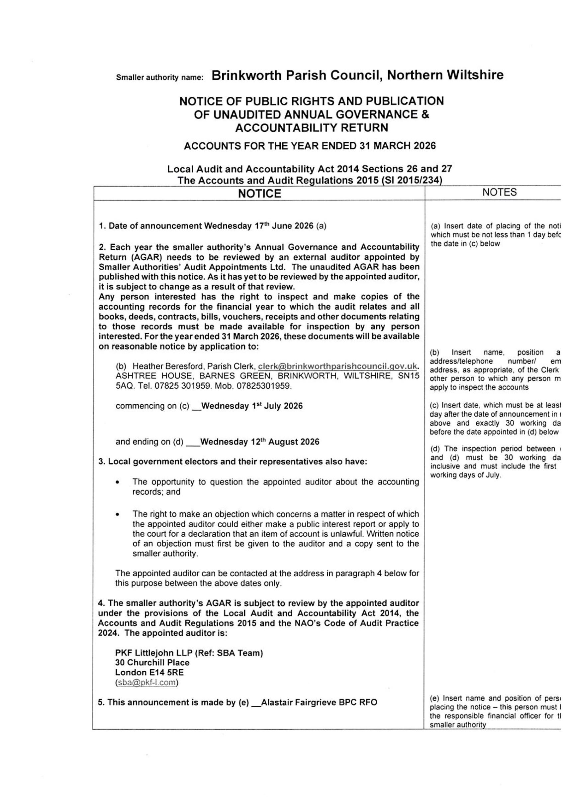
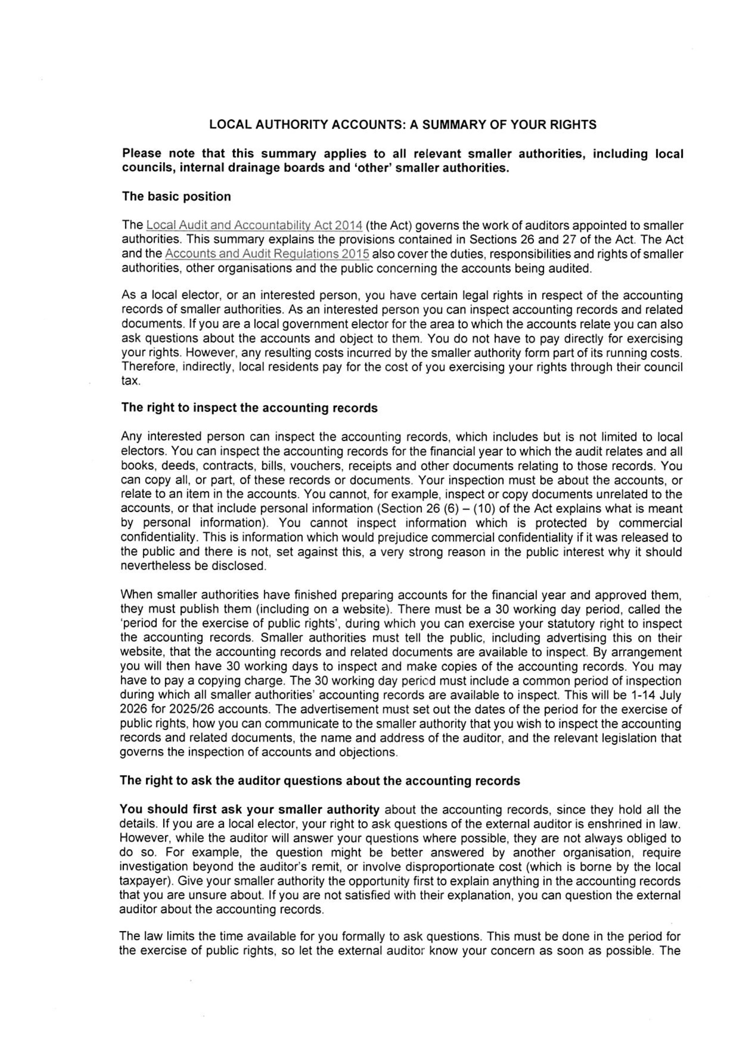
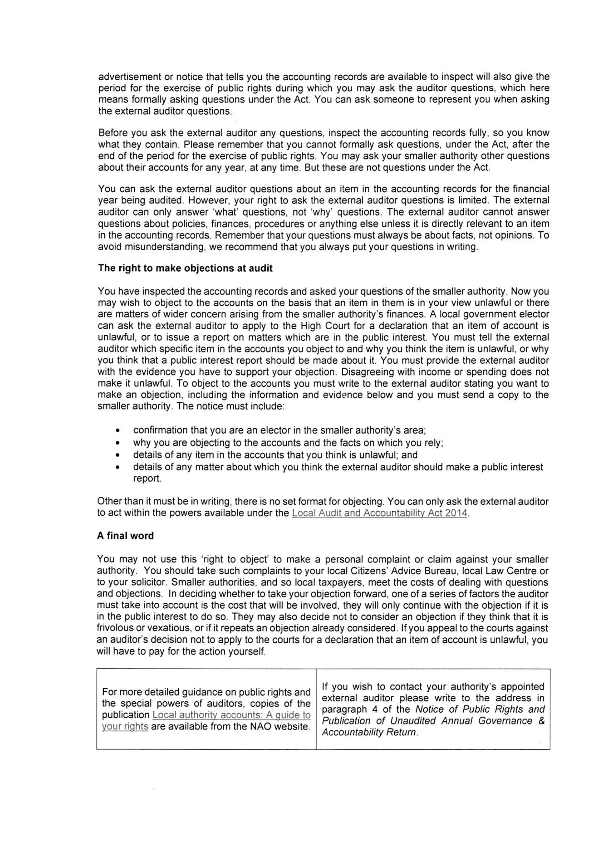



BY EMAIL

DDI:
+44 (0)20 7516 2200
Email: sba@pkf-l.com Date:
15 September 2025
Our Ref: WI0031 SAAA Ref: SB01305

Brinkworth Parish Council
Completion of the limited assurance review for the year ended 31 March 2025

Dear Brinkworth Parish Council

We have completed our review of the Annual Governance C Accountability Return (AGAR) for Brinkworth Parish Council for the year ended 31 March 2025. Please find our external auditor report and certificate (Section 3 of the AGAR Form 3) included for your attention as an attachment to the email containing this letter along with a copy of Sections 1 and 2 of the AGAR, on which our report is based.
The external auditor report and certificate details any matters arising from the review. The smaller authority must publish these documents immediately and at the next meeting consider the final external auditor report and decide what, if any, action is required.

Action you are required to take at the conclusion of the review

The Accounts and Audit Regulations 2015 (SI 2015/234) set out what you must do at the conclusion of the review. In summary, you are required to:
- Prepare a “Notice of conclusion of audit” which details the rights of inspection, in line with the statutory requirements. We attach a pro forma notice you may use for this purpose (a Word version is available on request).
- Publish the “Notice” along with the certified AGAR (Sections 1, 2 C 3) before 30 September 2025 ,
which must include publication on the smaller authority’s website. (Please note that when the statute and regulations were amended in 2014 and 2015, they did not include a requirement for the length of time for which that the “Notice” must be published. The previous statute required 14 days; but it is now up to the authority to make this decision).
- Keep copies of the AGAR available for purchase by any person on payment of a reasonable sum.
- Ensure that Sections 1, 2 and 3 of the published AGAR remain available for public access for a period of not less than 5 years from the date of publication.

PKF Littlejohn LLP, Chartered Accountants. A list of members’ names is available at the address below. PKF Littlejohn LLP is a limited liability partnership registered in England and Wales No. OC342572. Registered office at 15 Westferry Circus, London E14 4HD. PKF Littlejohn LLP is a member of PKF Global, the network of member firms of PKF International Limited, each of which is a separate and independent legal entity and does not accept any responsibility or liability for the actions or inactions of any individual member or correspondent firm(s).
PKF Littlejohn LLP
15 Westferry Circus, Canary Wharf, London E14 4HD
T: +44 (0)20 7516 2200
pkf-l.com

Fee
We enclose our fee note, on page 4 of this attachment, for the limited assurance review, which is in accordance with the fee scales set by Smaller Authorities' Audit Appointments Ltd which can be found at https://www.saaa.co.uk/audit-fees/. This fee is statutory, must be paid and is due immediately on receipt of invoice, please arrange for this to be paid at the earliest opportunity.
Additional charges are itemised on the fee note, where applicable. These arise where either:
- we have had to issue chaser letters and/or exercise our statutory powers due to a failure to provide an AGAR by the submission deadline; or
- it was necessary for us to undertake additional work.
Please return the remittance advice with your payment, which should be sent to: PKF Littlejohn LLP, Ref: Credit control (SBA), 5th Floor, 15 Westferry Circus, Canary Wharf, London, E14 4HD. Please include the reference WI0031 or Brinkworth Parish Council as a reference when paying by BACS.

Timetable for 2025/26

Next year we plan to set a submission deadline for the return of the completed AGAR Form 3 and associated documents (or Certificate of Exemption) in the usual way and this is expected to be Wednesday 1 July 2026. It is anticipated that the instructions will be sent out during March 2026, subject to arrangements for the 2025/26 AGARs and Certificates of Exemption being finalised by Smaller Authorities’ Audit Appointments Limited (SAAA). Our instructions will cover any changes about which smaller authorities need to be aware.
- The smaller authority must inform the electorate of a single period of 30 working days during which public rights may be exercised. The period must be exactly 30 working days, please do not set public rights dates that cover a longer period. This information must be published at least the day before the inspection period commences;
- The inspection period must include the first 10 working days of July 2026, i.e. 1 to 14 July inclusive. In practice this means that public rights may be exercised:
  - at the earliest, between Wednesday 3 June and Tuesday 14 July 2026; and
  - at the latest, between Wednesday 1 July and Tuesday 11 August 2026.
As in previous years, in order to assist you in this process we plan to include a pro forma template notice with a suggested inspection period on our website. On submitting your AGAR and associated documentation, as was the case for this year, we will need you to either confirm that the suggested dates have been adopted or inform us of the alternative dates selected.
We would like to draw your attention to a change within the Practitioners’ Guide 2025 which is mandatory for the 2025/26 period. Paragraphs 1.47 to 1.54 relate to an additional assertion to be included in the 2025- 26 AGAR, Assertion 10, regarding email management, websites, compliance with both the General Data Protection Regulation (GDPR) 2016 and the Data Protection Act (DPA) 2018 and the requirement to have an IT policy. The requirements in relation to Assertion 10 are listed in Paragraphs 1.47 to 1.54 and the local authority should review these requirements and take appropriate steps to ensure compliance.

Feedback on 2024/25

We would welcome feedback on your experiences with PKF Littlejohn LLP during the review for the year ended 31 March 2025. Such feedback is important to us to help us drive improvements in client service. If you wish to provide feedback, our satisfaction survey template can be used, which is available on our website on this page: https://www.pkf-l.com/services/limited-assurance-regime/useful-information-and- links/
Yours sincerely
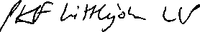
PKF Littlejohn LLP

Brinkworth Parish Council Notice of conclusion of audit
Annual Governance s Accountability Return for the year ended 31 March 2025

Sections 20(2) and 25 of the Local Audit and Accountability Act 2014 Section 16 of the Accounts and Audit Regulations 2015 (SI 2015/234)

- The audit of accounts for Brinkworth Parish Council for the year ended 31 March 2025 has been completed and the accounts have been published.

- The Annual Governance C Accountability Return including the auditor’s certificate and opinion is available for inspection and copying by any local government elector of the area of Brinkworth Parish Council on application to:

(a)

Notes

This notice and Sections 1, 2 C 3 of the AGAR must be published by 30 September. This must include publication on the smaller
authority’s website. The smaller authority must decide how long to publish the Notice for; the AGAR and external auditor report must be publicly available for 5 years.

- Insert the name, position and address of the person to whom local government electors should apply to inspect the AGAR

(b)

- Insert the hours during which inspection rights may be exercised

